# Which are the most lucrative chemical industries that can be setup in India?

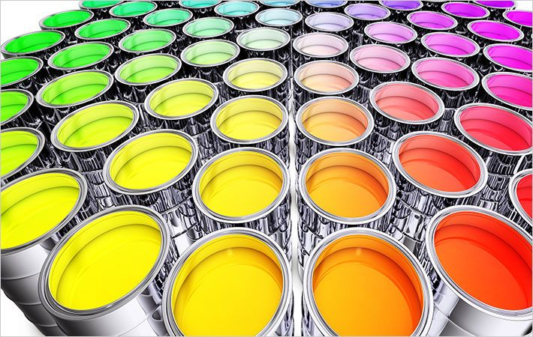

India is known to be the sixth largest producer of Chemicals in the world and third largest in Asia and is known to be a key constituent of Indian economy, accounting for about 2.11% of GDP. India has been accounted to have exported 10.3% of chemicals in the year 2016-17 in total export.

The most lucrative chemical manufacture and export that steal the market is ***Dye and Dye Intermediates***. India is not only known to be a colourful country but also at exporting the same. India manufactures wide ranges of dye for textile, leather, paper, ink, plastic and paint industries. It does not give up on the quality and it meets International standards. The export of Dye and Dye Intermediaries touched 2,363.58 million in 2017-18 with an increase of 14.13% when compared to last year.

If Dye were the highest selling, then by-product used to make them i.e. ***Inorganic Chemicals*** would weigh next in the market chain. The inorganic chemicals are a foremost source in manufacturing industries. Some of the main inorganic chemicals are sulphuric acid, nitric acid, alkaline, soda ash and caustic soda which are main ingredients in manufacturing of fertilizers, synthetic fibres, plastics, paints, dyes It is also used in metallurgy, leather tanning and oil refining, common salt, coal, glass, paper, detergents wherein most of the above mentioned products are consumed on a daily basis by common people not just the industries.

***Drugs and Pharmaceuticals*** – India is known to be the largest supplier of generic drugs globally. Pharmaceutical industry has succeeded to accelerate globalization by providing over 50% of vaccines, 40% of generic drugs (US), 25% of medicines (UK). The industry was valued at USD $33 billion in 2017 and India’s pharmaceutical exports stood at US$ 17.27 billion in 2017-18.

With digitalization in place, India has been able to adapt latest technologies like the Internet of Things, machine learning and block chain which will start acting as game-changers in the [chemical industry](http://bit.ly/3181nBK). India had set up, up to USD 80 Million for up-gradation in 12th 5year plan for chemical Industry. With various [Chemical Consulting industries](http://bit.ly/3181nBK) in the market that provide services in market research and forecasting, applying innovation, strategic thinking and new technologies, an entry into the [chemical industry](http://bit.ly/3181nBK) is now effortless.

Company phone no: 080-42171111

Website: [www.solutionbuggy.com](http://www.solutionbuggy.com)

Email: sales@solutionbuggy.com